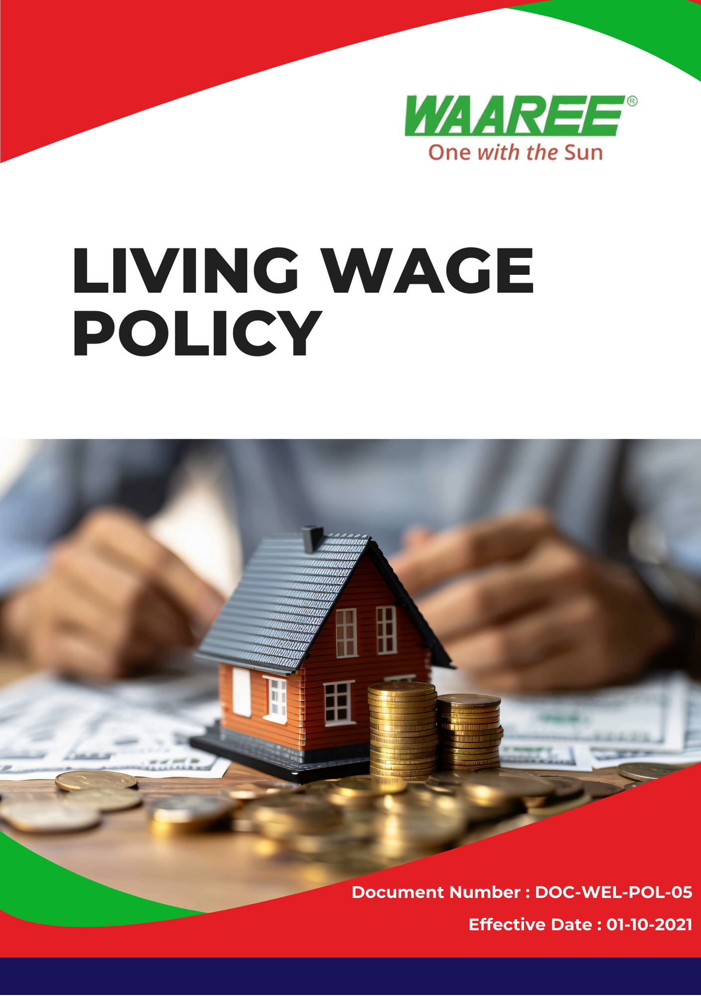
Index

❖ Introduction: 3
❖ Scope: 3
❖ Living Wage Commitment: 3
❖ Quantitative Targets: 4
❖ Action Framework: 5
❖ Roles and Responsibilities: 5
❖ Monitoring and Reporting: 5
❖ Communication and Transparency: 6
❖ Continuous Improvement: 6
❖ SDGs (Sustainable Development Goals) Covered in the Living Wage Policy 6
❖ Review: 7
❖ Employee Acknowledgement – Waaree Energies Ltd.(Group) Living Wage Policy 8

Introduction:
At Waaree Energies Ltd. (Group), we are committed to promoting fair and equitable wages for all employees, ensuring that every worker earns a wage that allows them to meet their basic needs and enjoy a decent standard of living. This Living Wage Policy reflects our commitment to fostering a work environment where every employee is valued and compensated fairly, aligning with global standards for human rights and labor practices. Through this policy, Waaree aims to contribute to the well-being of its workforce and support economic stability within the communities in which we operate.

Scope:
This policy applies to all internal employees and contract workers of Waaree Energies Ltd. (Group), including full-time, part-time, and temporary workers, across all our operations sites, which we mention below. For some business units, the living wage target covers a partial scope, where specific employee groups are prioritized. It extends to suppliers and partners, ensuring that all parties engaged with Waaree uphold living wage principles.

Sr. No. | Manufacturing Plant | Address
1 | Gujarat – Surat | Plot No. 231 – 236, Surat Special Economic Zone, Diamond Park Sachin, Surat 394230, Gujarat
2 | Gujarat – Tumb | Survey No. 38/1, Tumb Village, Tumb, Umbergaon, Valsad, Gujarat – 396150
3 | Gujarat – Chikhli | WAAREE SHREE GODIJI FACTORY, New Survey no. 1928 Village Degam, Taluka, Chikhli, Gujarat 396530
4 | Gujarat –Nandigram | CBIPL NANDIGRAM Unnamed Road, Nandigam, Gujarat 396105

Living Wage Commitment:
Waaree Energies Ltd. is dedicated to ensuring that all employees and contract workers are compensated with a living wage, which is defined as the minimum income necessary for workers to meet their basic needs, such as food, housing, healthcare, and education, and maintain a dignified quality of life. Our living wage commitment includes:
- Wage Standards Above the Legal Minimum: Waaree is committed to paying wages that exceed the legal minimum wage in the regions where we operate. We ensure that wages are sufficient to cover basic living expenses, providing workers with a wage that promotes financial independence and well-being.
- Basic Needs Coverage: A living wage ensures that employees and contract workers can meet their basic needs such as food, housing, transportation, education, healthcare, and savings. Waaree assesses local living conditions and ensures that wages reflect the actual cost of living in each region.
- Equal Pay for Equal Work: Waaree is committed to gender pay equity and ensuring that there is no wage discrimination based on gender, race, age, or any other personal characteristic. We promote fair and equal pay for all employees and contract workers performing similar roles and with comparable qualifications and experience.
- Continuous Wage Assessment: Waaree regularly reviews and updates its wage structures to reflect changes in the cost of living, inflation, and market conditions. In some specific business units, wage assessments will focus on selected employee groups, while the full living wage policy applies globally to all internal employees and contract workers. We ensure that wages remain aligned with local living costs and adjust salaries accordingly to maintain wage equity across all operations.

Quantitative Targets:
- Sets 2022 as the Baseline for tracking our living wage compliance and employee compensation performance.

- Living Wage Implementation:
- Ensure 100% of internal employees and contract workers across selected business units or regions are paid a living wage by 2025.
- Conduct annual reviews of wage structures to ensure they reflect the cost of living and inflation rates in each region, prioritizing business units in the first phase of implementation.
- Wage Equity and Gender Pay Parity:
- Achieve 100% gender pay parity across all internal employees and contract workers by 2025.
- Ensure that no wage gaps exist based on gender, race, or any other discriminatory factors by conducting regular pay audits.
- Supplier and Contractor Compliance:
- By 2025, ensure that 100% of high-priority suppliers and contractors engaged by Waaree comply with living wage standards.
- Conduct annual audit of high-risk suppliers to ensure compliance with fair wage policies.

Action Framework:
- Annual Wage Reviews: Waaree will conduct annual wage reviews to assess whether internal employees and contract workers in selected business units are earning a living wage. These reviews will take into account local living costs, inflation rates, and economic conditions.
- Pay Audits: Regular pay equity audits will be conducted to ensure that there are no gender or race-based wage disparities among internal employees and contract workers. Any discrepancies found will be corrected immediately, and the results will be shared with management for continuous improvement.
- Supplier Code of Conduct: All suppliers and contractors are required to adhere to Waaree’s Supplier Code of Conduct, which mandates that they pay their employees a living wage. Suppliers failing to meet these standards will be required to implement corrective actions or risk termination of contracts.
- Employee Feedback: Waaree will establish an open communication platform where employees and contract workers can report wage-related concerns, such as inequity or unfair compensation. This will allow the company to address issues proactively and ensure wage policies are being upheld.

Roles and Responsibilities:
- Human Resources Department: Responsible for ensuring the implementation of the living wage policy, conducting wage reviews, and overseeing compliance with wage equity standards for internal employees and contract workers in all applicable business units and regions.
- Compliance Team: The compliance team will conduct regular audits of suppliers and contractors to ensure they adhere to living wage standards and uphold fair labor practices.
- Supervisors and Managers: Responsible for ensuring that all internal employees and contract workers under their supervision are paid fairly and that wage policies are adhered to. They will also ensure that any wage-related issues raised by employees are addressed promptly.
- Suppliers and Contractors: Suppliers and contractors must adhere to Waaree’s living wage standards and are required to provide transparent wage data for their employees. Waaree will conduct annual audit to ensure compliance.

Monitoring and Reporting:
- Annual Living Wage Report: Waaree will publish an annual living wage report detailing the company’s progress toward meeting its living wage goals for internal employees and contract workers. This report will include wage review results, pay equity audit findings, and supplier compliance data.
- Employee Feedback and Surveys: Waaree will conduct regular employee surveys to gauge employee satisfaction with their wages and benefits. Feedback from these surveys will be used to inform wage reviews and policy adjustments.
- Supplier Audits: Waaree’s compliance team will conduct annual audit of high-priority suppliers and contractors to ensure that they are paying their workers a living wage. Any non-compliance will result in immediate corrective actions or termination of contracts.

Communication and Transparency:
- Waaree’s Living Wage Policy will be made publicly available on the company website and communicated internally to all employees and contract workers through employee handbooks, newsletters, and training sessions.
- Waaree will engage with suppliers and contractors to ensure they fully understand the living wage requirements and are supported in meeting these standards. This includes providing training on wage equity and human rights.

Continuous Improvement:
Waaree Energies Ltd. is committed to continuously improving its wage practices to ensure that all internal employees, contract workers, suppliers, and contractors receive fair compensation. Our living wage strategy will roll out in phases across business units, with the goal of full implementation by 2025. We will regularly update this policy to reflect changes in local living standards, inflation, and market conditions. Our goal is to set a benchmark for fair wages in the renewable energy sector and ensure that every worker is treated with dignity and respect.

SDGs (Sustainable Development Goals) Covered in the Living Wage Policy




Review:
The Living Wage Policy will be reviewed annually by the Human Resources Department in collaboration with the Compliance Team. This review will assess progress towards meeting the outlined targets, evaluate the effectiveness of the policy, and ensure alignment with evolving legal requirements and best practices in labor rights. Any necessary adjustments will be communicated to all employees, contract workers, suppliers, and partners.

Approved By:

Designation:

Last Review Date: 01/04/2024 Next Review Date: 01/04/2025

Employee Acknowledgement – Waaree Energies Ltd.(Group) Living Wage Policy
I acknowledge that I have received, read, and understood the Waaree Energies Ltd. (Group) Living Wage Policy. I am aware of the company’s commitment to promoting fair and equitable wages for all employees and ensuring that every worker earns a wage that meets their basic needs and supports a decent standard of living.

I understand my role in supporting this policy, which includes adhering to the wage standards set forth by Waaree, advocating for equal pay for equal work, and ensuring compliance with all applicable labor laws and regulations. I agree to participate in discussions regarding wage-related concerns and to provide feedback for continuous improvement of our wage practices.

Furthermore, I will actively support efforts to foster a fair and equitable work environment, report any wage discrepancies or concerns, and contribute suggestions for enhancing our Living Wage Policy. By signing below, I confirm my commitment to upholding the Waaree Energies Ltd. (Group) Living Wage Policy and supporting the company’s mission to ensure that every worker is treated with dignity and respect.

Employee Name:

Employee Signature:

Date:

